Testing the High-Voltage Power Supply Board

Servicing a SuperDARN Transceiver  
Step 7

Content

1. Introduction 3

2. Instructions 3

3. Conclusion 4

# Introduction

This document provides work instructions for testing the High-Voltage Power Supply Board in a SuperDARN transceiver box. Before attempting to implement these instructions, be sure to complete all the preceding steps in the procedure for Servicing a SuperDARN Transceiver.

# Instructions

Following are the step-by-step instructions for testing the High-Voltage Power Supply Board. In the case of unforeseen problems occurring, apply electronic fault-finding techniques. Refer to *Figure 1* for component and connection locations.

1. It is strongly recommended that protective eyewear is worn whenever the chassis is open and the HV Supply is live.
2. Connect the Phoenix connector between the Power Distribution Board (**J5**) and the HV Supply Board (**J2**).
3. Disconnect the HV Supply from the High-Power Switch at **J2**.
4. Switch on the 15 V power from the front plate.
5. Apply 3.3 V to the STC. This will enable the 50 V, lighting up **D5** on the HV Supply Board. Measure the HV output (grey wire) using the DMM.
6. **CAUTION!** The output is at 850V. Adjust the **R5** potentiometer to set the voltage - you should measure something around 850V.
7. First power off the 3.3 V and wait for **D5** to go off. Now switch off the 15 V supply.

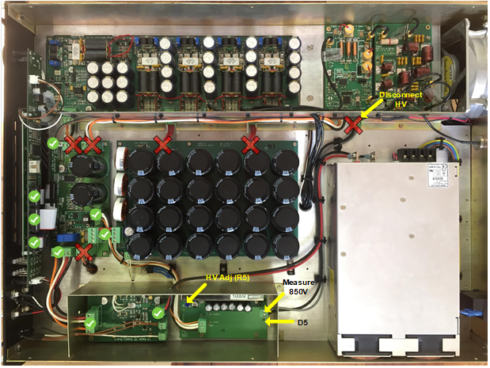

Figure . Important connections and components related to the HV Supply Board.

# Conclusion

This concludes the work instructions for testing the High-Voltage Power Supply Board of a SuperDARN transceiver box. The next step in the procedure for Servicing a SuperDARN Transceiver is to test the High-Power Switch.